In order to receive CEUS, you must complete both sections:
Play for All: Adapting Play for Children with Severe Neuro-Motor Challenges to Increase Functioning and
Fun with Family and Friends
Webinar 13 2025
CEU Evaluation Form
Underline/highlight/circle the answer that you wish to indicate.

- Content of the materials presented was: Not Useful Neutral Useful
- Duration of the presentations was: Too Long About Right Too Short

3. Research evidence and outcomes data
were used to support the presentations:

Disagree Neutral Agree

4. I think the impact of this work on my
clients who use assistive technology will be:
Adverse Neutral Beneficial

- I was provided with feedback on my ability to master the learning objectives:

- The information I learned will support my ability to collect data and measure outcomes as part of my evidence-based practices:

Disagree Neutral Agree

Disagree Neutral Agree

- I think the following could be improved:
- I think the following was particularly good / useful:
- In my assessment, my continuing education needs that relate to achieving the most effective communication for my clients who use assistive technology include the following:
- Underline items if you are 1) a member of ASHA; 2) a teacher; 3) an OT; 4) a PT; 5) a member of RESNA; 6) an ATP; 7) an ATS; 8) other: .

Play for All: Adapting Play for Children with Severe Neuro-Motor Challenges to Increase Functioning and

Fun with Family and Friends

Webinar 13 2025

Learning Assessment Form

Name: ____________________________________________ Date: _________________
In order to pass a participant must score an 80% or higher. Underline/highlight/circle the answer that you wish to indicate. Please answer the following questions:

1. Which is not one of the three key guidelines for adapted play?
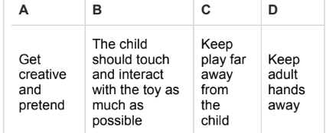

2. Which F word is not included in the F Words of Childhood Disability?
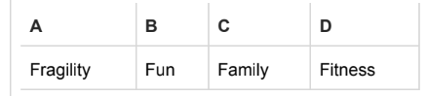

3. Research shows that children with Cerebral Palsy demonstrate decreased participation in play. ____True _____False

4 What is the best reason for using a switch adapted toy for play?
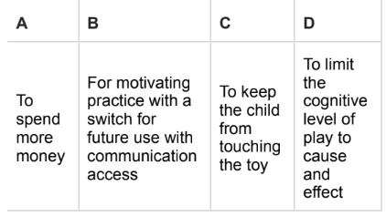
5. There is no evidence that play is a useful treatment tool for children receiving therapy?
____True _____False

Please note any suggestions for improving this activity in terms of learning value. _______________________________________________________________________________________________________________

