In order to receive CEUS, you must complete both sections:
Beyond Translation: Building Robust Bilingual AAC with Minspeak
Webinar 12 2025
CEU Evaluation Form
Underline/highlight/circle the answer that you wish to indicate.

- Content of the materials presented was: Not Useful Neutral Useful
- Duration of the presentations was: Too Long About Right Too Short

3. Research evidence and outcomes data
were used to support the presentations:

Disagree Neutral Agree

4. I think the impact of this work on my
clients who use assistive technology will be:
Adverse Neutral Beneficial

- I was provided with feedback on my ability to master the learning objectives:

- The information I learned will support my ability to collect data and measure outcomes as part of my evidence-based practices:

Disagree Neutral Agree

Disagree Neutral Agree

- I think the following could be improved:
- I think the following was particularly good / useful:
- In my assessment, my continuing education needs that relate to achieving the most effective communication for my clients who use assistive technology include the following:
- Underline items if you are 1) a member of ASHA; 2) a teacher; 3) an OT; 4) a PT; 5) a member of RESNA; 6) an ATP; 7) an ATS; 8) other: .

Beyond Translation: Building Robust Bilingual AAC with Minspeak

Webinar 12 2025

Learning Assessment Form

Name: ____________________________________________ Date: _________________
In order to pass a participant must score an 80% or higher. Underline/highlight/circle the answer that you wish to indicate. Please answer the following questions:

1. Sequential bilingual language development occurs when an individual is exposed to and learns two languages at the same time.
_____True _____False

2. The process of learning a second language while maintaining and reinforcing an individual's first language and culture is known as:
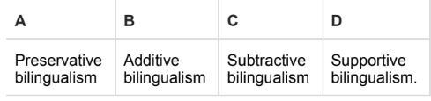
3. A lack of focus on learning the home language can result in a decrease in engagement with an individual's family and community.
____True _____False

4 A bilingual individual using LAMP Words for Life can link monolingual Spanish, Canadian French, and/or English files using the Go to Vocabulary Tool.
____True _____False
5. Bilingual Minspeak systems support language and learning through
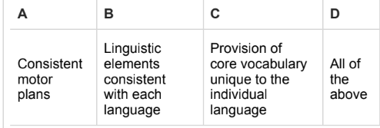

Please note any suggestions for improving this activity in terms of learning value.

____________________________________________________________________________________________________________________________________

