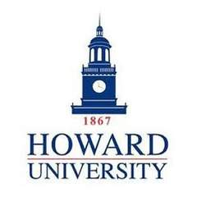
12th CAAC Research Conference
2019 Program-at-a-Glance

October 17-19, 2019
Howard University, Washington DC

Thursday, October 17
3:30 Registration Opens & Welcome Reception
5:00 Advanced Level Short Course – 2 hrs
Tele-AAC Practice for the Advanced Practitioner
Nerissa Hall & Ellen Cohn

Friday, October 18
8:00 Registration & coffee
8:30 Welcome & Overview of Research Issues – Howard University
9:00 Keynote Address: Research Directions Driven by AAC Speakers: Optimizing Communication for Employability
Chris Klein, Become AAC
10:00 Featured Presentation: NIDILRR’s Research Mission and Funding Mechanisms: Keys to Successful Grant Applications
Stephen Bauer, NIDILRR Program Officer
10:45 Break
11:00 RESEARCH PRESENTATIONS: Accepted Papers
12:30 LUNCH
1:30 RESEARCH PRESENTATIONS: Accepted Papers
4:15 Poster Session & Chair’s Reception
6:30 Adjourn

Saturday, October 19
8:00 Registration & continental breakfast
8:30 Panel on AAC Specialty Certification
9:30 RESEARCH PRESENTATIONS: Accepted Papers
11:00 Lyle L. Lloyd Discussion Forum
Measuring the Effectiveness of AAC Treatment
12:00 Closing & Award Ceremony
12:30 Adjourn and Visit Washington DC

