Short Course: Tele-AAC Practice for the Advanced Practitioner

Nerissa Hall and Ellen R. Cohn

Tele-AAC is the use of telepractice to provide services to individuals for use of Augmentative and Alternative Communication (AAC) systems. Tele-AAC, a relatively new application of telepractice, shows promise for offering cost-effective, expert services at a distance and in a variety of practice sites to underserved populations across the lifespan. The tele-AAC practitioner must be able to demonstrate advanced competencies in both AAC and telepractice. First, they must be expert in providing in-person AAC intervention, consultation and assessments before conducting them in the virtual world. Second, the overlay of telepractice on AAC practice requires a sophisticated grasp of the fundamentals of tele-ethics, policy, technology, privacy and safety, the current environment(s), and imminent trends. Third, the tele-AAC practitioner must seamlessly manage the technical demands of adapting AAC to the synchronous and asynchronous virtual environments, as well as facilitating clinical and educational team-based tele-collaboration. This workshop will guide attendees through the provision of tele-AAC for teams, and services, and demonstrate application of such services through a number of case examples. (167)

Learner Outcomes:
At the conclusion of this Short Course, participants will be able to:
1. Discuss requirements for lawful and ethical tele-AAC practice.
2. Describe technical requirements for the conduct of synchronous tele-AAC.
3. Critically analyze the use of tele-AAC in a case example.

Nerissa Hall, PhD, CCC-SLP, ATP
Founding Partner
Commūnicāre, LLC
Southwick, Massachusetts

Ellen R. Cohn, PhD, CCC-SLP, ASHA-F
Professor
Department of Communication Science and Disorders
School of Health and Rehabilitation Sciences
University of Pittsburgh
Pittsburgh, Pennsylvania
Susan Jones, CCC-SLP lives in Detroit and plans to add tele-AAC for clients in Pennsylvania (PA) and New York (NY) to her private practice. Which of the following is true about required state licensure?

- Since Ms. Jones holds SLP license in Michigan, no further licenses are required.
- A current CCC-SLP, a nationally recognized credentials precludes the need to obtain additional SLP licenses in PA and NY.
- Additional SLP licenses are required for Michigan licensed Ms. Jones to deliver tele-AAC services in both PA and NY.
- The national state license compact has eliminated the need for multiple state licenses.
- A and B

(Answer: b)

Due to budget shortages, XYZ Elementary School does not subscribe to an encrypted internet service. SLP Ms. Jones wishes to invite a representative of a company vendor to virtually observe a tele-AAC session and lend advice on system adaptations. The representative works at the corporate headquarters, but not in a private office. Which of the following is true?

- This arrangement violates privacy and security best practices.
- A Business Associate Agreement (BAA) is not required, since no payment is to be exchanged with the free and open internet service.
- It is acceptable for the school to borrow use of a neighbor’s encrypted internet service.
- It is acceptable for the vendor representative to work from local coffee shop using the free WiFi for the meeting.
- C and D

(Answer: a)

Maria received a referral for an AAC evaluation for an individual with cerebral palsy. She is eager to get started with the assessment and went ahead to schedule her assessment via tele-AAC. Which statement is most accurate regarding this scenario?

- It is appropriate for Maria to schedule this as soon as possible to avoid placing this individual on a waiting list.
- As tele-AAC is shown to be as effective as in-person services, Maria is free to choose to conduct the assessment in-person or via tele-AAC.
- Maria needs to determine whether or not tele-AAC is appropriate given this individual’s profile.
- Maria needs to ask the individual whether or not he or she is willing to complete the assessment via tele-AAC.
- All of the above

(Answer: c)

Jake is an experienced clinician who is familiar with LAMP Words for Life. He is working with a student using the app and is eager to use tele-AAC to involve the student’s family in the sessions. Which of the following is true?

- Jake can record his session to share with the family after his session using secure methods.
- Jake can work with the student and have the family concurrently join/view his session remotely.
- Jake can use a secure video conferencing tool to connect with the student and their family in their home to review skills being addressed in session, by screen-casting the app for the purposes of demonstration.
- B and C
- A, B, and C

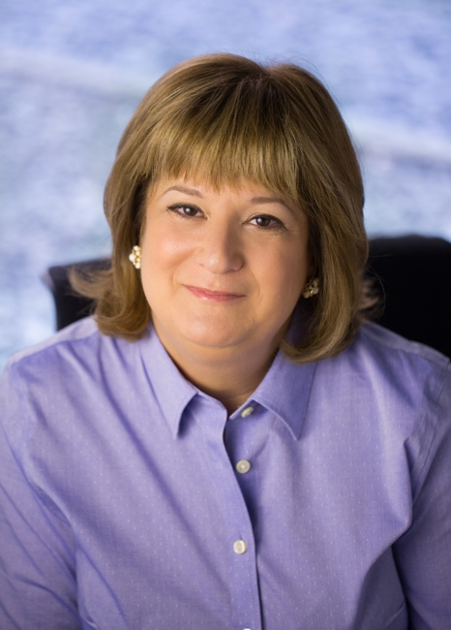
Ellen Cohn PhD, CCC-SLP, ASHA Fellow is professor at the Department of Communication Science of Disorders, University of Pittsburgh. She teaches courses in cleft palate/craniofacial disorders, professional issues, diversity and healthcare, and communication. Cohn has co-authored books on telerehabilitation, communication disorders casebook, cleft palate; diversity in higher education; and communication, is editor of the International Journal of Telerehabilitation. Cohn is a past investigator for RERC on Telerehabilitation. She was the founding coordinator of the ASHA Special Interest Group on Telepractice (#18) and is a past director of the American Telemedicine Association. (91
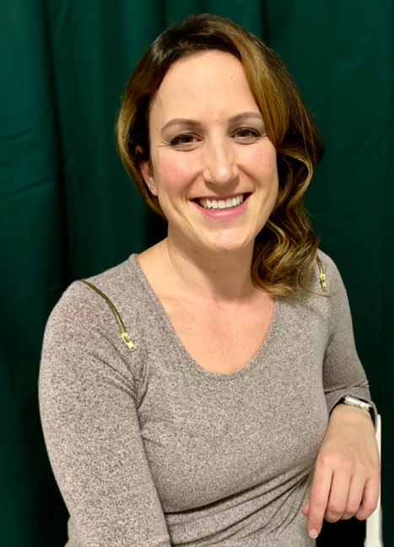

Nerissa Hall, PhD, CCC-SLP, ATP is co-founder of Commūnicāre, LLC, a company specializing in augmentative and alternative communication, assistive technology, and tele-AAC working primarily with school-aged individuals, providing specialized, evidence-based intervention, assessment and consultation services. Nerissa received her Master and Doctorate degrees from the University of Massachusetts-Amherst, focusing on tele-AAC, and has presented nationally regarding this and other related topics. Nerissa has served as a LEND Fellow, adjunct faculty at Elms, Cambridge College and the University of Massachusetts-Amherst. She is former Associate Editor of ASHA’s journal, Perspectives on Telepractice, and serves on the editorial board of this journal and others. (100)

